Page 1

Original Waveform

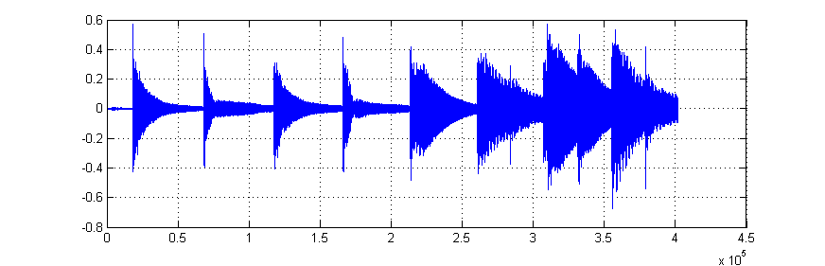

Original gamelan notation

7 6 7 6 5 3 5 3

Estimated waveform of Saron based on the template

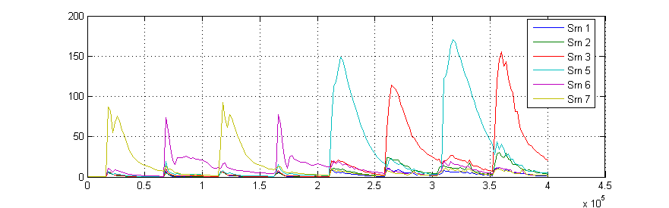

Estimated notation of Saron

7 6 7 6 5 3 5 3

Page 2

Original Waveform

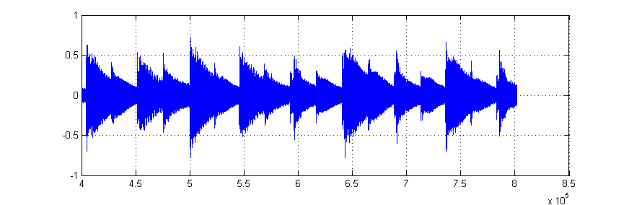

Original gamelan notation

5 3 5 3 6 5 6 5 6

Estimated waveform of Saron based on the template

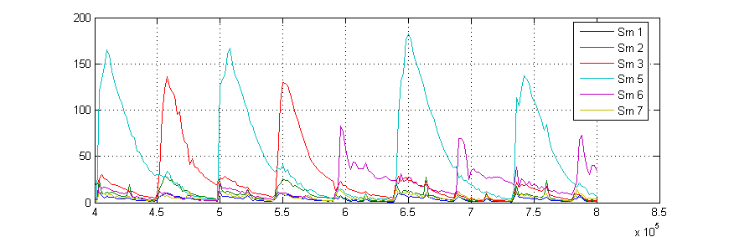

Estimated notation of Saron

5 3 5 3 6 5 6 5 6

Page 3

Original Waveform

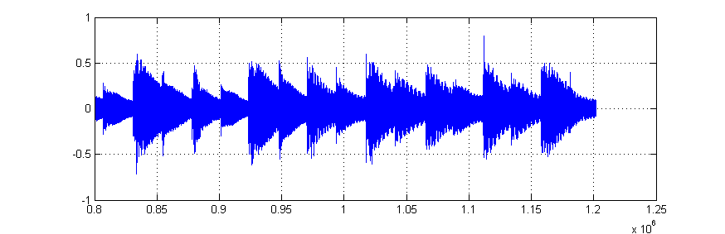

Original gamelan notation

5 6 5 3 2 3 2 3

Estimated waveform of Saron based on the template

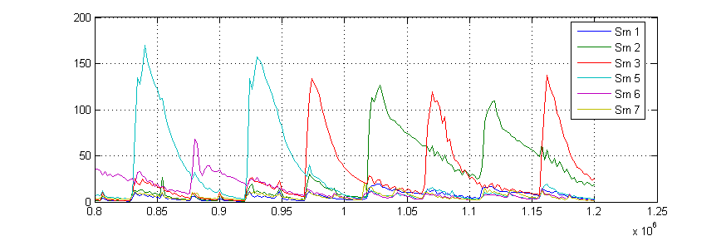

Estimated notation of Saron

5 6 5 3 2 3 2 3

Page 4

Original Waveform

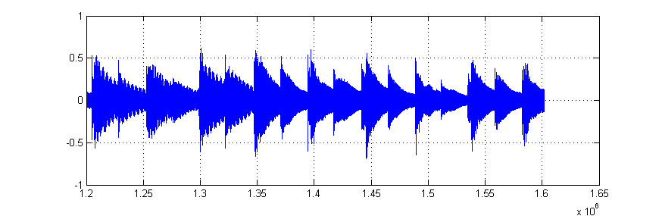

Original gamelan notation

2 3 2 7 6 7 6 7 6

Estimated waveform of Saron based on the template

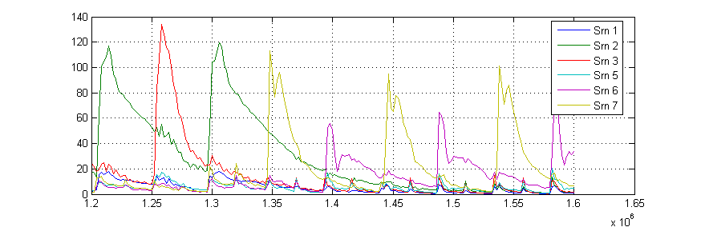

Estimated notation of Saron

2 3 2 7 6 7 6 7 6

Page 5

Original Waveform

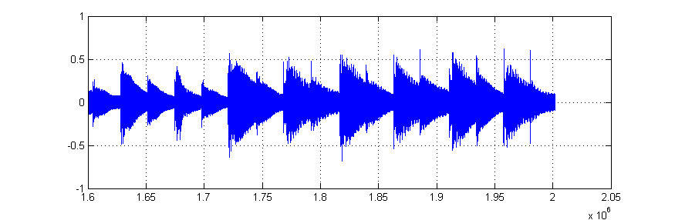

Original gamelan notation

7 6 5 3 5 3 5 3

Estimated waveform of Saron based on the template

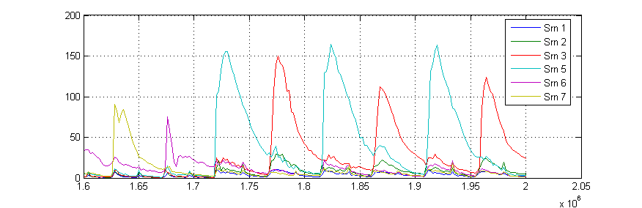

Estimated notation of Saron

7 6 5 3 5 3 5 3

Page 6

Original Waveform

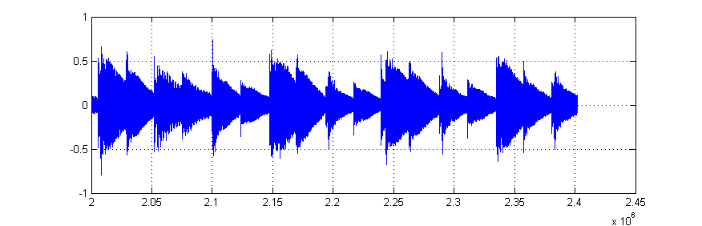

Original gamelan notation

5 3 6 5 6 5 6 5 6

Estimated waveform of Saron based on the template

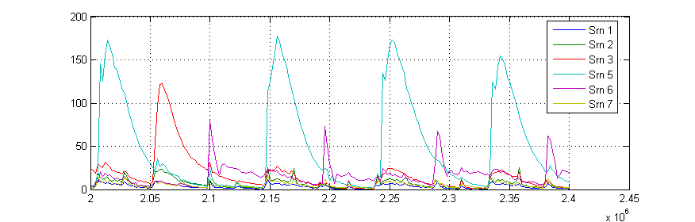

Estimated notation of Saron

5 3 5 5 6 5 6

Lost 6 6

Page 7

Original Waveform

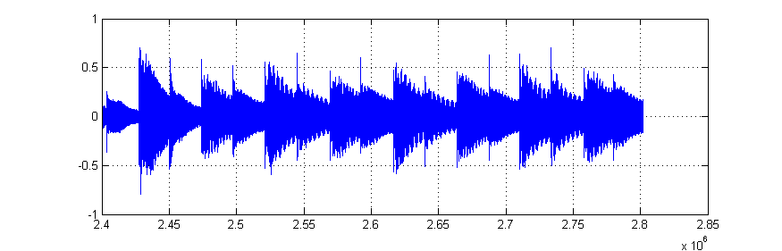

Original gamelan notation

5 3 2 3 2 3 2 3

Estimated waveform of Saron based on the template

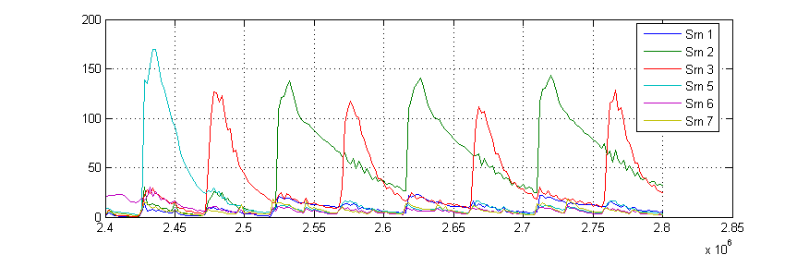

Estimated notation of Saron

5 3 2 3 2 3 2 3

Page 8

Original Waveform

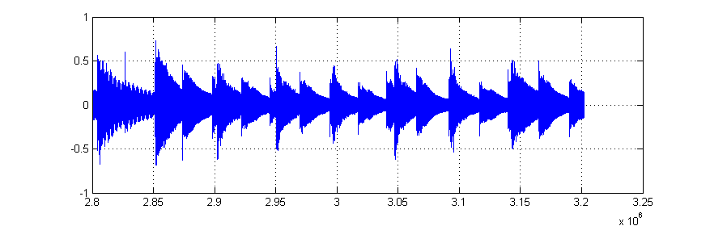

Original gamelan notation

2 7 6 7 6 7 6 5

Estimated waveform of Saron based on the template

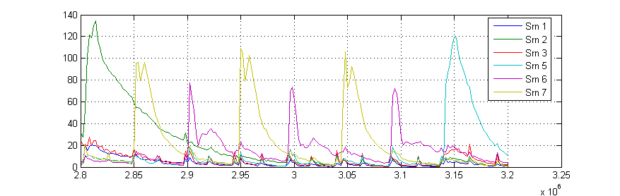

Estimated notation of Saron

2 7 6 7 6 7 6 5

Page 9

Original Waveform

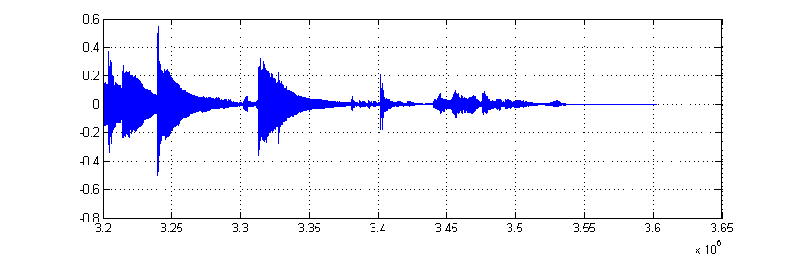

Original gamelan notation

7 3

Estimated waveform of Saron based on the template

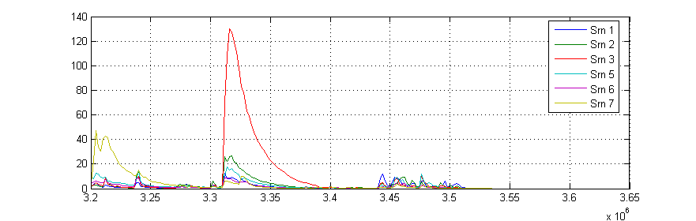

Estimated notation of Saron

1. 3